NT6 General Epistles (Emphasis on Hebrews)
Dr. Marvin J. Effa
Author: Although not stated, the best argument seems to be Paul. One can understand why he would not use his name, given the hostility between him and the Hellenists (Acts 9:29). A Pauline authorship also makes sense of Peter’s comments about Paul (2 Peter 3:15). Peter is writing to believing Jews (cf. 2 Peter 3:1 with 1 Peter 1:1). But the identity of the author remains unknown.
Date of writing: Dates range from 64 – 69 A.D.
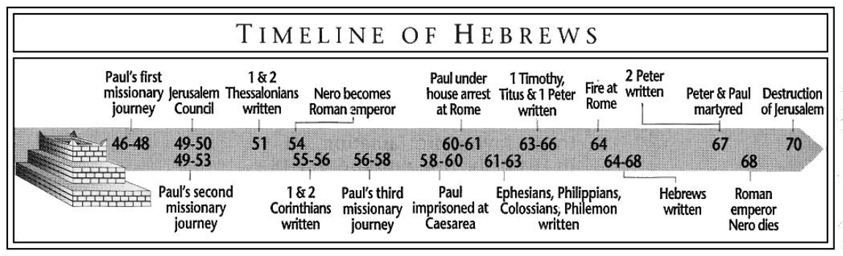
Purpose: to encourage Jewish believers to not withdraw from the struggling Christian church.
Idea: Become a partaker with Christ; do not withdraw unto judgment.
Development:
- Introductory theme: Jesus says it all, 1:1-4.
- He is God’s exalted king, 1:5-4:16.
  - He rules all creation, including angels, 1:5-14.
    - WARNING: hold fast or be judged, 2:1-4.
  - He, as king, is our perfected leader, 2:5-18.
    - WARNING: hold fast or be judged, 3:1-19.
    - WARNING: enter His rest or be judged, 4:1-16.
- He is God’s appointed high priest, 5:1-10:39.
  - He is appointed as priest by God, 5:1-11.
    - WARNING: grow and God will reward; don’t grow and God will judge, 5:12-6:20.
  - Christ, as high priest, is superior to all others, 7:1-10:39.
    - Christ’s priesthood annuls the Mosaic Law, 7:1-28.
    - The New Covenant is better than the Old Covenant, 8:1-13.
    - The new place of sacrifice is better than the old, 9:1-14.
    - The new sacrifice is better than the old, 9:15-10:18.
    - WARNING: draw near, hold fast, and consider, or be judged, 10:19-39.
- Believe God and be obedient, 11:1-12:29.
  - Faith is foundational to knowing God, 11:1-40.
  - Everyone who knows God is disciplined, 12:1-11.
    - WARNING: don’t be discouraged and withdraw or God will destroy you, 12:12-29.
- Words on Christian living, 13:1-25.
James
Author: James, the half-brother of Jesus and the head of the church in Jerusalem.
Date of writing: 45-48 A.D.
Purpose: to explain to Jewish believers how to handle trials and not be hurt by them.
Idea: When going through trials, be swift to hear the Word, slow to speak, and slow to wrath.
Development:
- Recognize the value of trials, James 1:1-18.
  - Trials strengthen our faith, 1:1-8.
  - Trials change our values, 1:9-11.
  - Trials reveal our true commitments, 1:12-18.
- Respond biblically to trials, James 1:19-4:17.
  - Welcome the Word and save the life, 1:19-2:26.
    - Overview of the book, 1:19-20.
    - Welcome the Word, 1:21-27.
    - Partiality is not “welcoming” the Word, 2:1-13.
      - The church should not show partiality, 2:1.
      - Wealth is a temptation for the church, 2:2-4.
      - Each situation in life has advantages and disadvantages, 2:5-7.
      - Treat others the way you wish to be treated, 2:8.
      - Evil judges show partiality, 2:4, 9-11.
    - Jesus will judge believers who do not “welcome the Word,” 2:12-26
      - We will be judged by our acts of kindness, 2:12-13.
      - Only faith coupled with works will deliver from judgment, 2:14-20.
      - Abraham demonstrated his faith, 2:21-23.
      - There are two justifications in the Bible, 2:24.
      - Rehab demonstrated her faith, 2:25.
      - Working faith is how we welcome the Word, 2:26.
  - We must control our tongue to avoid being hurt by trials, 3:1-18.
    - If we control the tongue we control the man, 3:2-4.
    - If we don’t control the tongue we destroy the man, 3:5-12.
    - Godly teachers must control the tongue, 3:1, 13-18.
  - We must be slow to wrath to avoid being hurt by trials, 4:1-16.
    - Conflicts come from our worldliness, 4:1-6a.
    - Humility is the cure for conflicts, 4:6b-16.
      - Humility toward God, 4:6b-10.
      - Humility toward the Brethren, 4:22-12.
      - Humility toward ourselves, 4:13-16.
  - Do every good thing, 4:17.
- During trials, rest in the return of Christ, James 5:1-11.
  - Judgment upon oppressors is certain, 5:1-6.
    - Give it away before it spoils, 5:2-3.
    - Treat the ones we owe with fairness, 5:4.
    - Reduce our pleasure seeking, 5:5.
    - Help those needier than ourselves, 5:6.
  - Christ’s soon return gives us endurance, 5:7-11.
    - Wait for the Lord, 5:7-8.
    - Don’t grumble, 5:9.
    - Remember the Prophets, 5:10.
    - Remember Job, 5:11.
- Remember James’s specific exhortations, James 5:12-20.
  - Don’t swear, 5:12.
  - Pray, 5:13a.
  - Sing, 5:13b.
  - Call, 5:14-15.
  - Confess, 5:16-18.
  - Convert, 5:19-20.

1 Peter
Author: Peter, the apostle of Jesus Christ, 1 Peter 1:1.
Date of writing: 64 A.D.
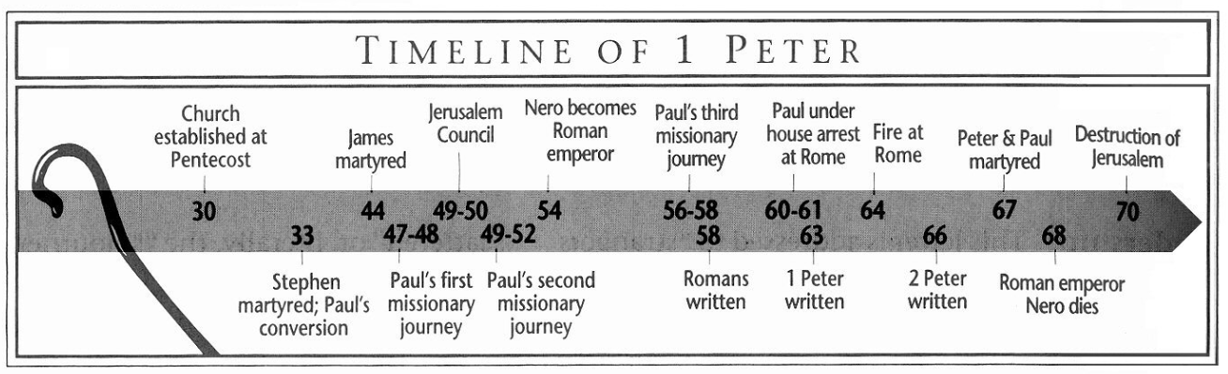
Purpose: to help Jewish Christians survive in a hostile land.
Idea: Suffering should lead us to deference in all relationships when we consider Christ’s example and our future glory
Development:
- Greetings to believers encountering unfair circumstances, 1:1-2.
- Our future glory encourages us during unfair circumstances, 1:3-2:10.
  - Our trials have value to God, 1:3-7.
  - Our salvation is worth waiting for, 1:8-12.
  - Our hope can make us holy, 1:13-16.
  - Reverent fear should characterize our lives, 1:17-21.
  - We are to long for the Word, 1:22-25.
  - The believer’s behavior should be righteous to avoid shame 2:1-10.
- Suffering believers should behave with deference in all relationships, 2:11-5:11.
  - Honorable conduct proves the truthfulness of Christianity, 2:11-12.
  - Submit to rulers, 2:13-17.
  - Servants, submit like the Servant, 2:18-25.
  - Defer in domestic relations, 3:1-7.
  - Defer in all relationships, 3:8-12.
  - Defer when encountering unfair treatment in civil spheres, 3:13-4:19.
- Final words for believes encountering unfair circumstances, 5:12-14.

2 Peter
Author: Simon Peter, a servant and apostle of Jesus Christ, 2 Peter 1:2.
Date of writing: 67-68 A.D.
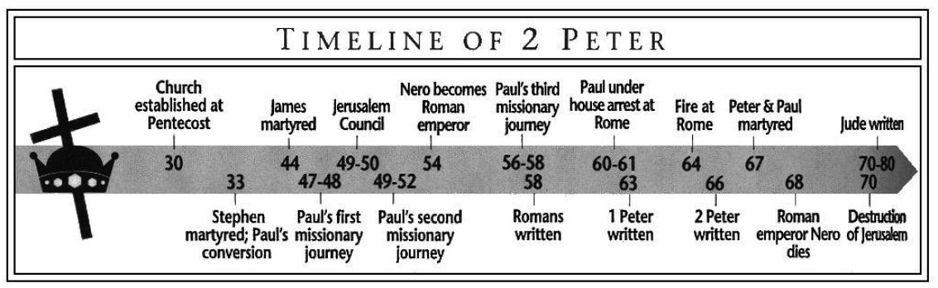
Purpose: to warn Jewish believers about false teachers who will deny the Lord and His return.
Idea: Use biblical knowledge to identify and defeat false teachers.
Development:
- The challenge of spiritual maturity is built on the sure foundation of Scripture, 1:1-21.
  - The apostolic faith is complete, 1:1-4.
  - It is sufficient for a fruitful believer to have an abundant entrance into the kingdom, 1:5-11.
  - An established faith rests in God’s glorious Son and His trustworthy Word, 1:12-21.
- A ringing polemic against false teachers who mislead God’s people, 2:1-22.
  - False teacher basics, 2:1-3.
  - God will judge the wicked and deliver the righteous, 2:4-9.
  - False teachers are rebels, 2:10-12.
  - False teachers are professional philanderers and unholy hustlers, 2:12-17.
  - False teachers truly want you in their bondage, 2:18-22.
- How we should live in light of false teacher’s denial of Christ’s return, 3:1-18.
  - In spite of the scoffers, we can count on Christ’s promise to return, 3:1-9.
  - Be ready for the return of Christ, 3:10-13.
  - Four commands and a comment, 3:14-18.

1 John
Author: John the Apostle.
Date of writing: The date cannot be determined with certainty.
Purpose: While several themes are found in 1 John, the book is written to provide assurance of salvation to the end that close fellowship with Christ will protect against false doctrine and carnal living.
Idea: Your relationship to Jesus can be as close as the Apostles.
Development:
- The Apostles’ fellowship with God is available to us, 1:1-4.
- The sin problem must be resolved, 1:5-2:2.
  - God is sinless, 1:5.
  - Sins we don’t know about are resolved, 1:6-7.
  - Sins we do know about are resolved, 1:8-10.
  - We have an Advocate who satisfies the Father for everyone, 2:1-2.
- Love is essential, 2:3-11.
- We can always become closer to Jesus, 2:12-14.
- Fellowship includes warfare, 2:15-27.
  - Warfare against the world, 2:15-17.
  - Warfare against the Antichrist, 2:18-27.
- Make the apostle’s message your own, 2:28-5:5.
  - By abiding in Christ, 2:28.
  - By abiding in purity, love, and doctrine, 2:29-5:5.
    - We must be pure, 2:29-3:9.
    - We must love one another, 3:10-23.
    - We must maintain sound doctrine, 3:24-4:6.
    - Doctrine should lead to love, 4:7-11.
    - Doctrine that leads to love should lead to purity, 4:12-5:5.
- Security makes abiding possible, 5:6-21.

2 John
Author: John the Apostle.
Date of writing: The date cannot be determined with certainty.
Purpose: to provide instructions to churches regarding traveling cultists.
Idea: Don’t help the cultist!
Development:
- Christianity is all about truth, 1-3.
- Love requires obedience to the Bible, 4-6.
- Deceivers damage believers, 7-11.
  - They deny essential doctrines, 7.
  - Believers are damaged by their doctrines, 8.
  - Fellowship with God requires sound doctrine, 9.
  - Fellowship with the church requires sound doctrine, 10-11.
- Some issues can’t wait! 12-13.
3 John
Author: John the Apostle.
Date of writing: The date cannot be determined with certainty.
Purpose: How to handle a good church with a bad leader.
Idea: Do not let evil leaders stop the missionary work.
Development:
- Obedience brings joy, 1-4.
- Help the Missionaries, 5-8.
- Bad church leaders are recognizable, 9-12.
  - They are the center of the church, 9.
  - They talk evil about others, 10a.
  - They misuse their office, 10b.
- Welcome those with a good testimony, 12-14.

Jude
Author: Jude, the half-brother of Jesus, and the brother of James, Jude 1.
Date of writing: The date is uncertain, but thought to be between 70 and 80 A.D.
Purpose: to encourage believers to fight for the faith.
Idea: Believers are to contend for the faith by fighting against false teachers.
Development:
- Believers are the ones addressed, 1-2.
- False teachers are always a problem, 3-4.
- False teachers have recognizable characteristics, 5-16.
  - Apostasy is part of history, 5-10.
  - False teachers have always been ungodly, 11-16.
- Don’t be swayed, but stay in the faith, 17-26.
  - Don’t be swayed because we knew of their coming, 17-19.
  - Develop your own faith: prayer, love, prophecy, and evangelism, 20-23.
  - God can keep us from their fate, 24-25.

